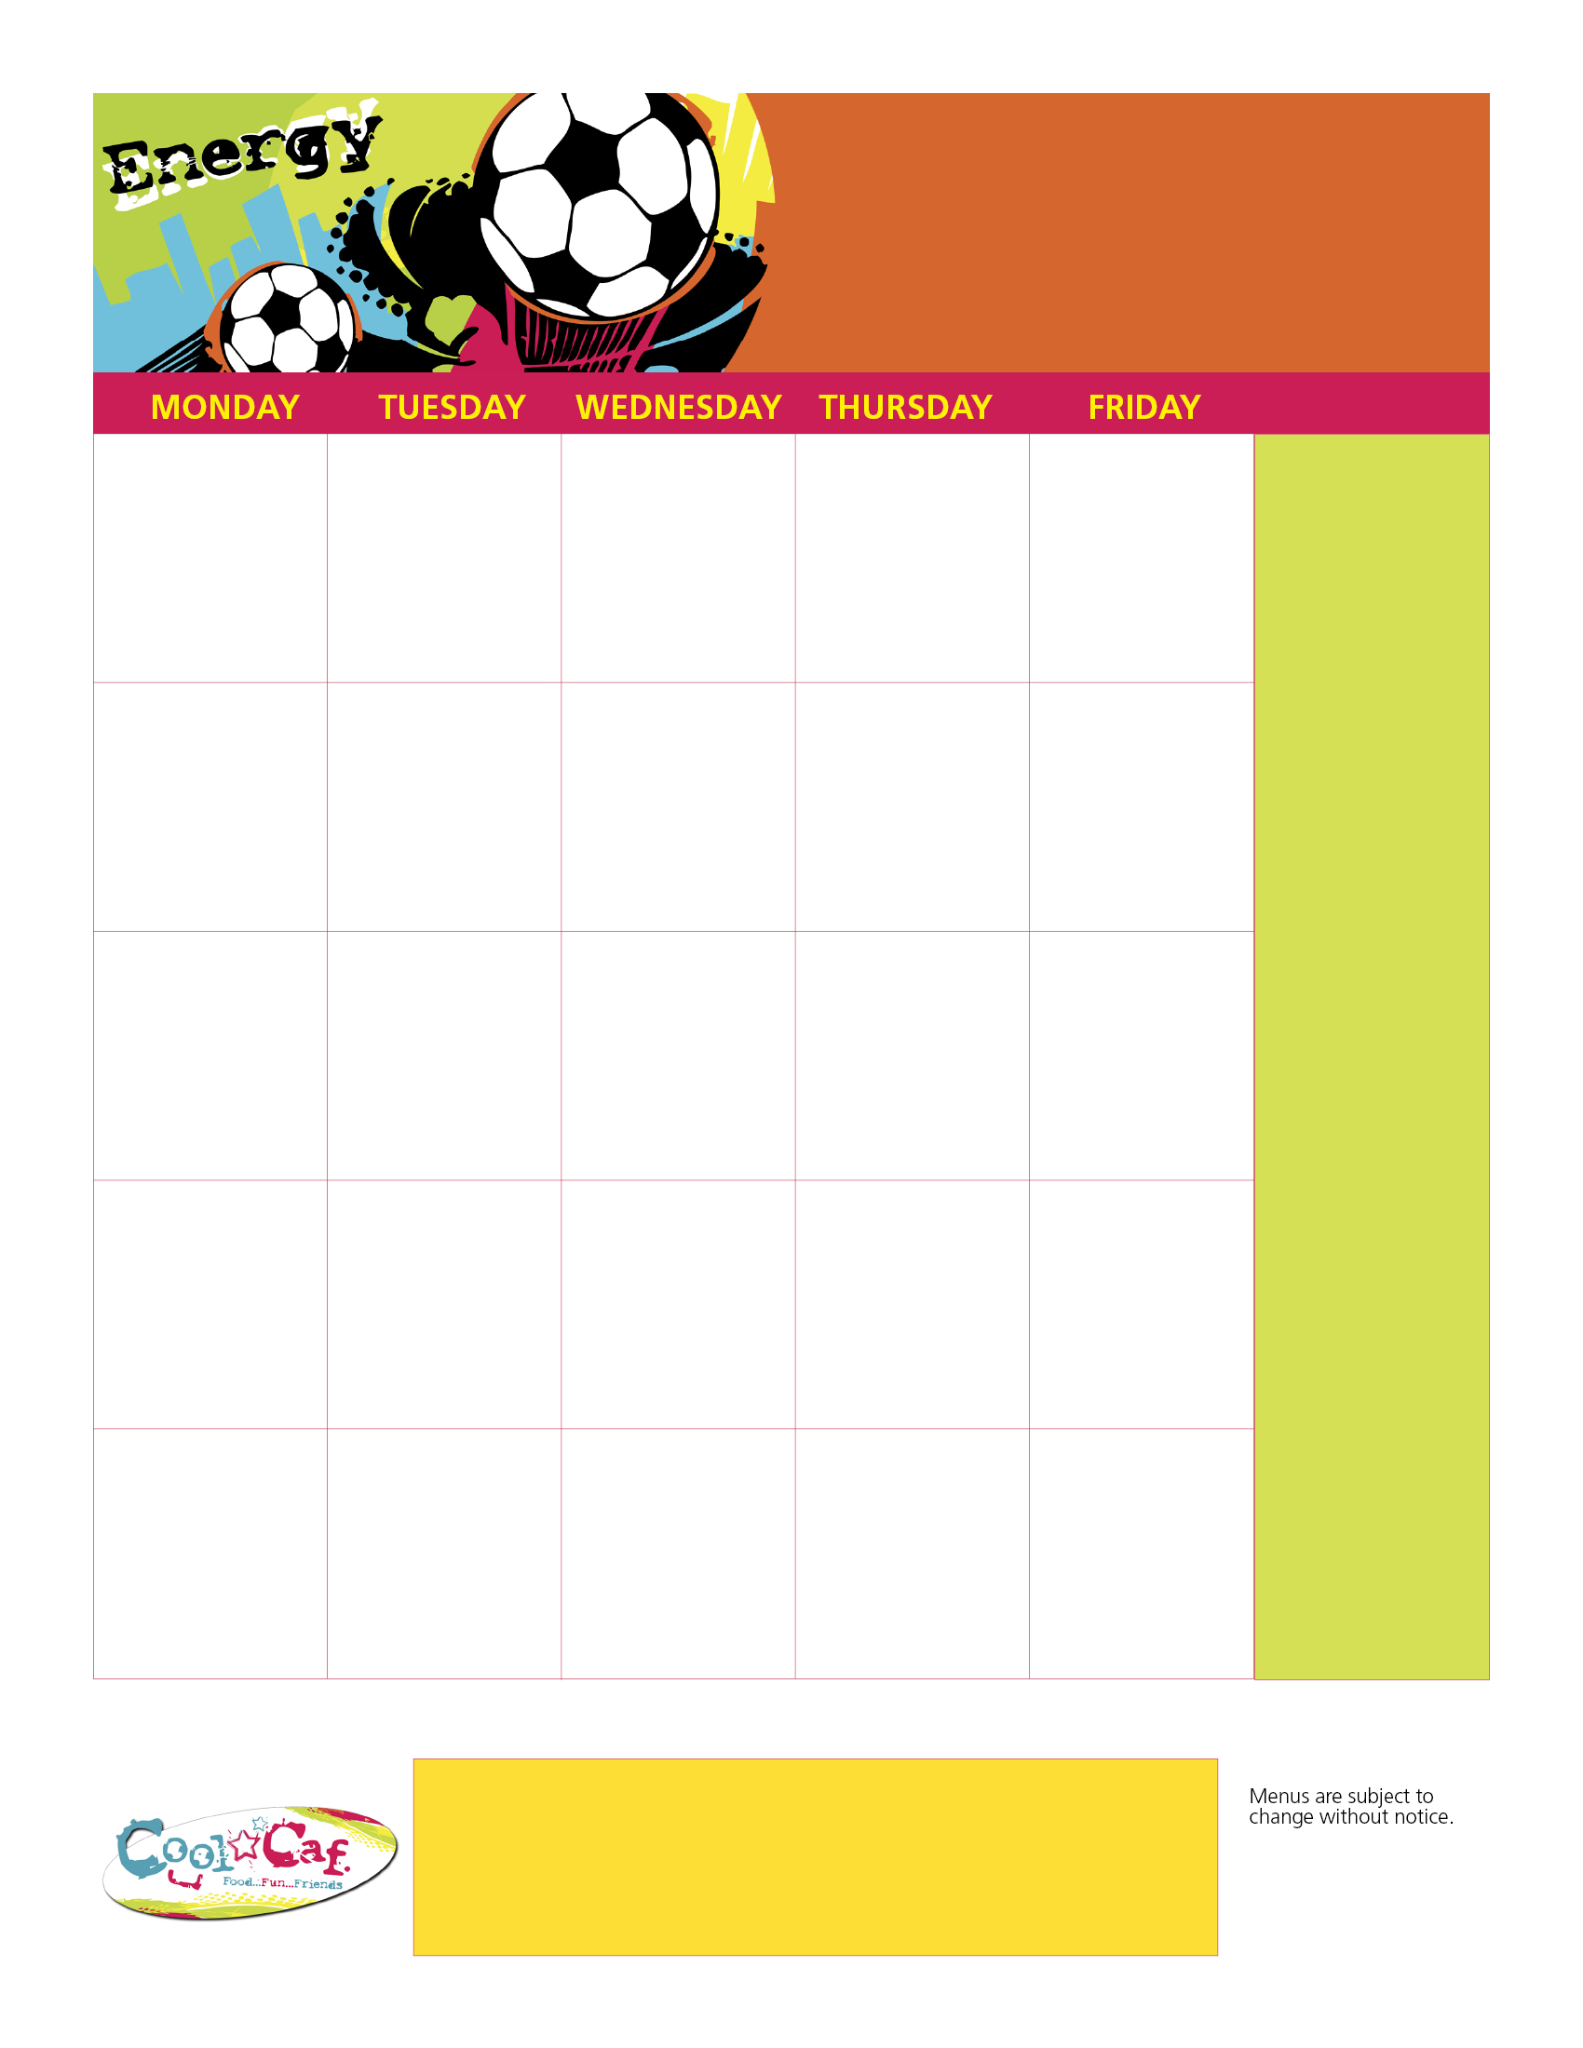

All meals come with a choice of milk & the fruit/veggie bar. Fruit/veggie bar offers rotating items like: romaine, broccoli carrots, cucumbers, tomatoes,celery & more. Fruit items like: apples, bananas, oranges,pears, peaches, applesauce, mixed fruit & more.

Breakfast Prices:

Full Pay: $1.25

Reduced: $ .30

Lunch Prices:

Full Pay: $2.25

Reduced: $ .40

Hot Breakfast Daily!

**Pizza**

**Corn**

**Elementary Menu**

**Please bring all meal accounts current. Thank you!!!!**

**Dundee Elementary Lunch Menu**

Have a GREAT summer!!!

**7**

**Cook’s Choice**

**Vegetable Choice**

**6**

**5**

**Hot Dogs**

**Hamburgers**

**French Fries/Tator Tots**

**4**

**Mexican Variety**

**Refried Beans**

**3**

**Chicken Variety**

**Peas & Carrots**

**2013**

**June**

**More Info…**

**Use this space to highlight menu items/ beverages that are served every day to leave the date boxes for special items only.**

**Adjust type size ac-cordingly.**

Aramark_Education-sml